Master Functional Document

Application | NGERP - Centra
Service Bundle | Master Management
Service Request | Tax Rate

Description :

Tax Rate Master is used the calculate the tax rate and itdefines the GL accounts each tax rate should be posted.

Workflow Process :

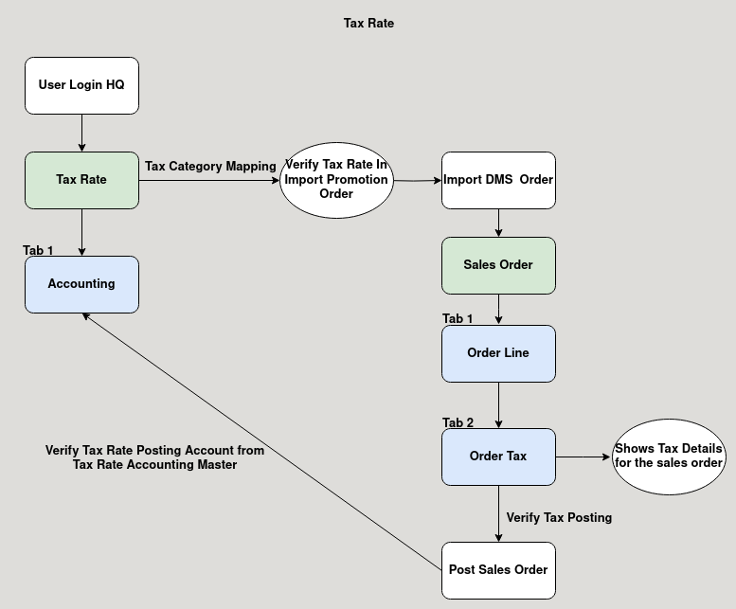
Business Rules :

- Tax Rate can be only added in HQ.
- The tax rate is set in the rate field.
- Accountig Tab is used to map the GL Account.
- For example when importing a Promotion order from DMS with the tax rate.
- It checks the tax rate from the tax master and calculate the tax amount for the promotion order.
- After posting the tax amount will be posted in the accounts defined in the Tax Rate Accounting Master.

